Information Security and Assurance

Encryption, Scanning, Packet Inspection

In this lab we will scan networks for vulnerabilities and inspect network packets, specifically noting encryption of data going across our networks.

For each task with an asterisk (\*) add a screenshot (full screen, do not crop). If it’s on a command take the screenshot after pressing enter.

Revert the DC system then Start it and wait 30 seconds

Revert the MS system, then Shutdown, then Start it

Start Wireshark on the host VM you are using:

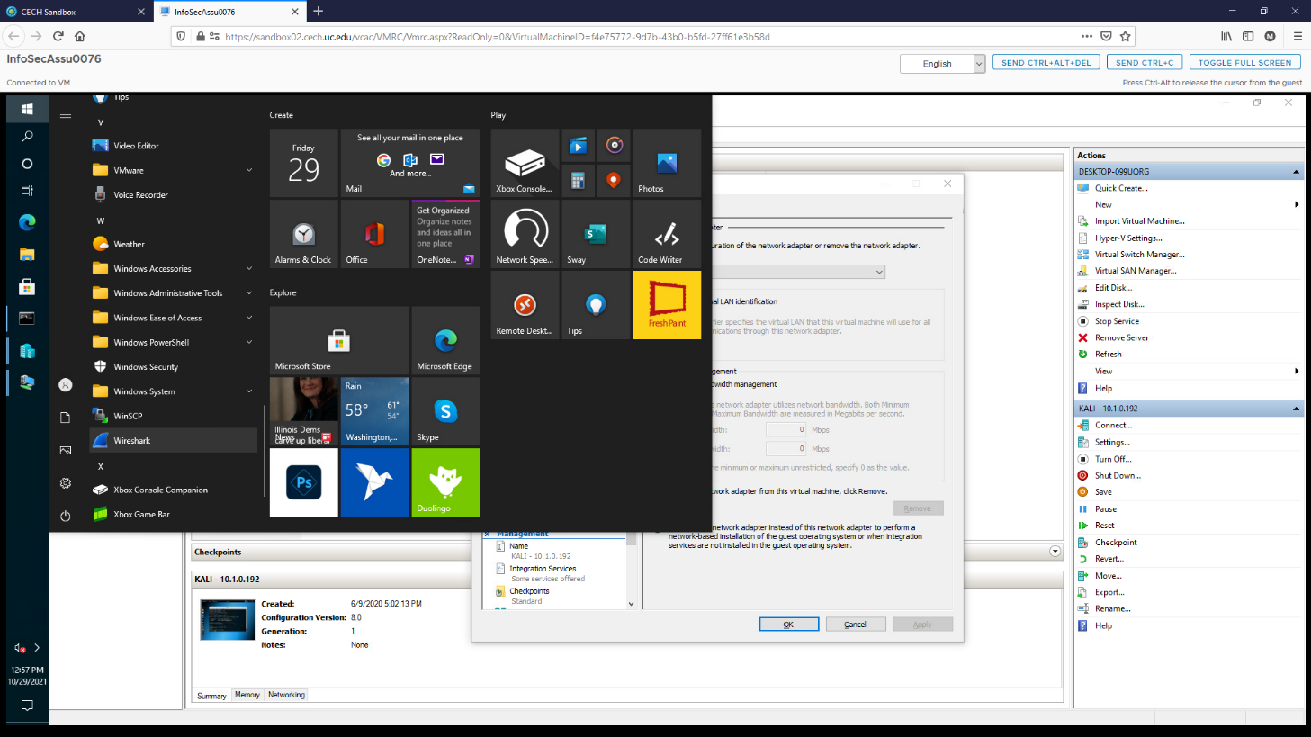

Choose Ethernet0 network card and start capturing packets by clicking the fin icon:

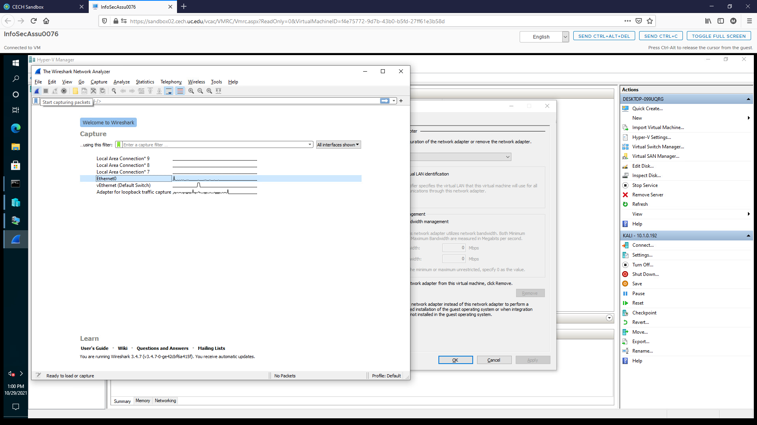

Open a command prompt:

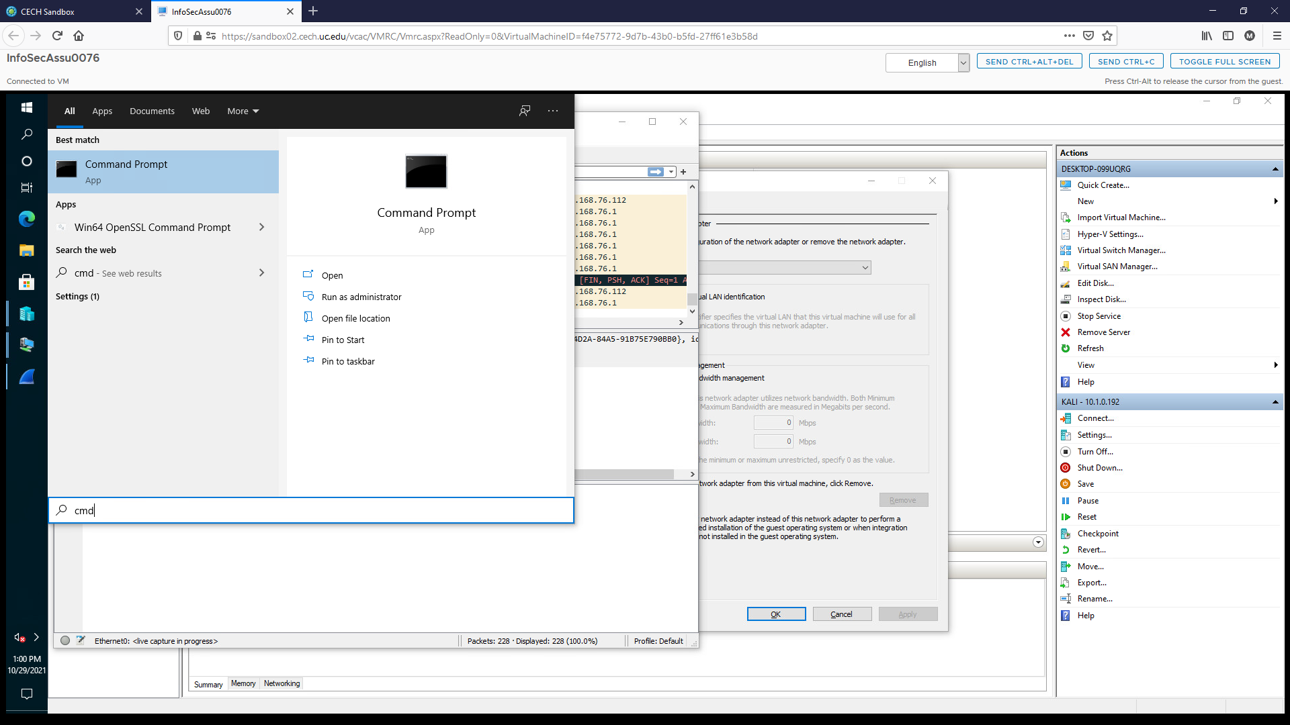

Log into the FTP server ftp.dlptest.com by typing:

ftp ftp.dlptest.com

Use your last name for a username and any password you like (it will fail to log in but that is ok, don’t choose a real password you use as others may see it).

Exit the FTP terminal by typing:

quit

Lookup the IP address of the FTP server by typing:

\* nslookup ftp.dlptest.com

What is the IP address of the FTP server?

Do a trace route to this server:

\* tracert ftp.dlptest.com

What does this information show us?

Is the IP address of the FTP server a public or private address? How do you know?

Stop the packet sniffer with the stop button next to the fin.

Look for packets with a destination ip address of the ftp server by sorting by Destination then clicking on each packet.

\* What is the MAC address of the FTP server?

Take screenshots of the packets containing your username and your password.

\* Why were you able to see this information?

We are running this packet capture software on the system sending and receiving the information. Could the packets be obtained by other systems on my network? How?

Start a packet capture again (no need to save the former capture).

Open a web browser on your VM and go to uc.edu

Stop the capture.

\* Lookup the IP address of this URL using nslookup.

In your Wireshark results find a packet going to or from this address then follow the TCP stream:



What does this show you? Why is the information scrambled?

Put the Kali and LAMP systems on the vLocal network in HyperV

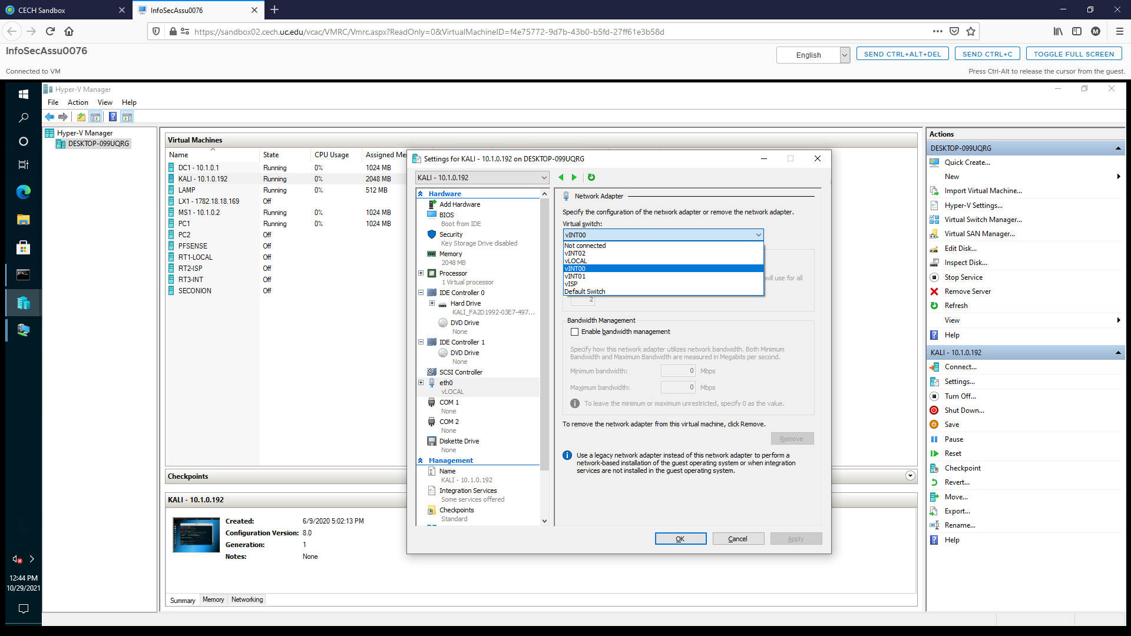

Start/connect to the LAMP VM (lamp/Pa$$w0rd)

The other systems are on the 10.1.0.0/24 network, so we need to put the LAMP server on the same network.

Type this into the command line:

sudo ifconfig eth0 10.1.0.111 netmask 255.255.255.0

Start (or restart if it’s running) the Kali VM and connect to it (root/Pa$$w0rd)

Perform a network scan on the network by typing:

\* nmap 10.1.0.0/24

What information does this provide to you? How can it be helpful for a system administrator, information security professional, and hacker?

Note that the SSH port is open for one of the systems, presumedly a web server since it also has the http port open.

Start a Wireshark capture in Kali.

SSH is a remote access into another system (a bit like FTP).

Start a Wireshark capture in Kali.

Let’s log into the server using SSH by typing the following and using Pa$$w0rd for the password:

\* ssh -l lamp 10.1.0.111

Open a browser on the Kali system and go to the website of the system (10.1.0.111).

Stop the packet capture.

\* Find the SSH packets in the capture.

Can you see the username/password like you did with the FTP previously? Why or why not?

\* Follow the http stream of packets.

What does this show you?

Why was it not scrambled?